Question 2 (Testing CAPM)

1. Data Samples and Data Sources

Risk-free rate 2013.1--2018.12 (csmar)

上证A股 2013.1--2018.12 (csmar)--consider reinvestment

上证指数 2013.1--2018.12 (csmar)

2.Empirical Analysis

2.1.Problem a

2.1.1.Get ‘rM-rf’

First we use the index at the end of each month to calculate the index rate of return, and record it as ‘rM’.

Then we use the ‘rM-rf’ at each month to get the data.

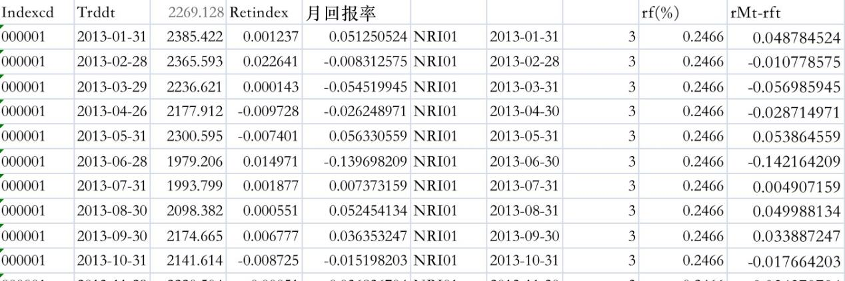

2.1.2 Get ‘rit-rft’

We use Excel to classify individual stocks by month, and subtract the risk-free interest rate from the corresponding individual stock yield to get ‘rit-rft’.

And then put ‘rit-rft’ and ‘rMt-rft’ into one Excel.

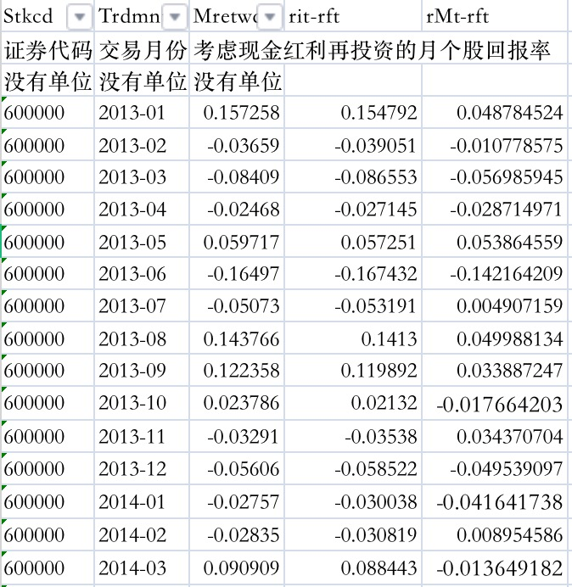

2.1.3 Linear Regression.

We use the Matlab to get the data from Excel, then regress x and y,as the code shown below.(The code has been marked with comments.)

Code:

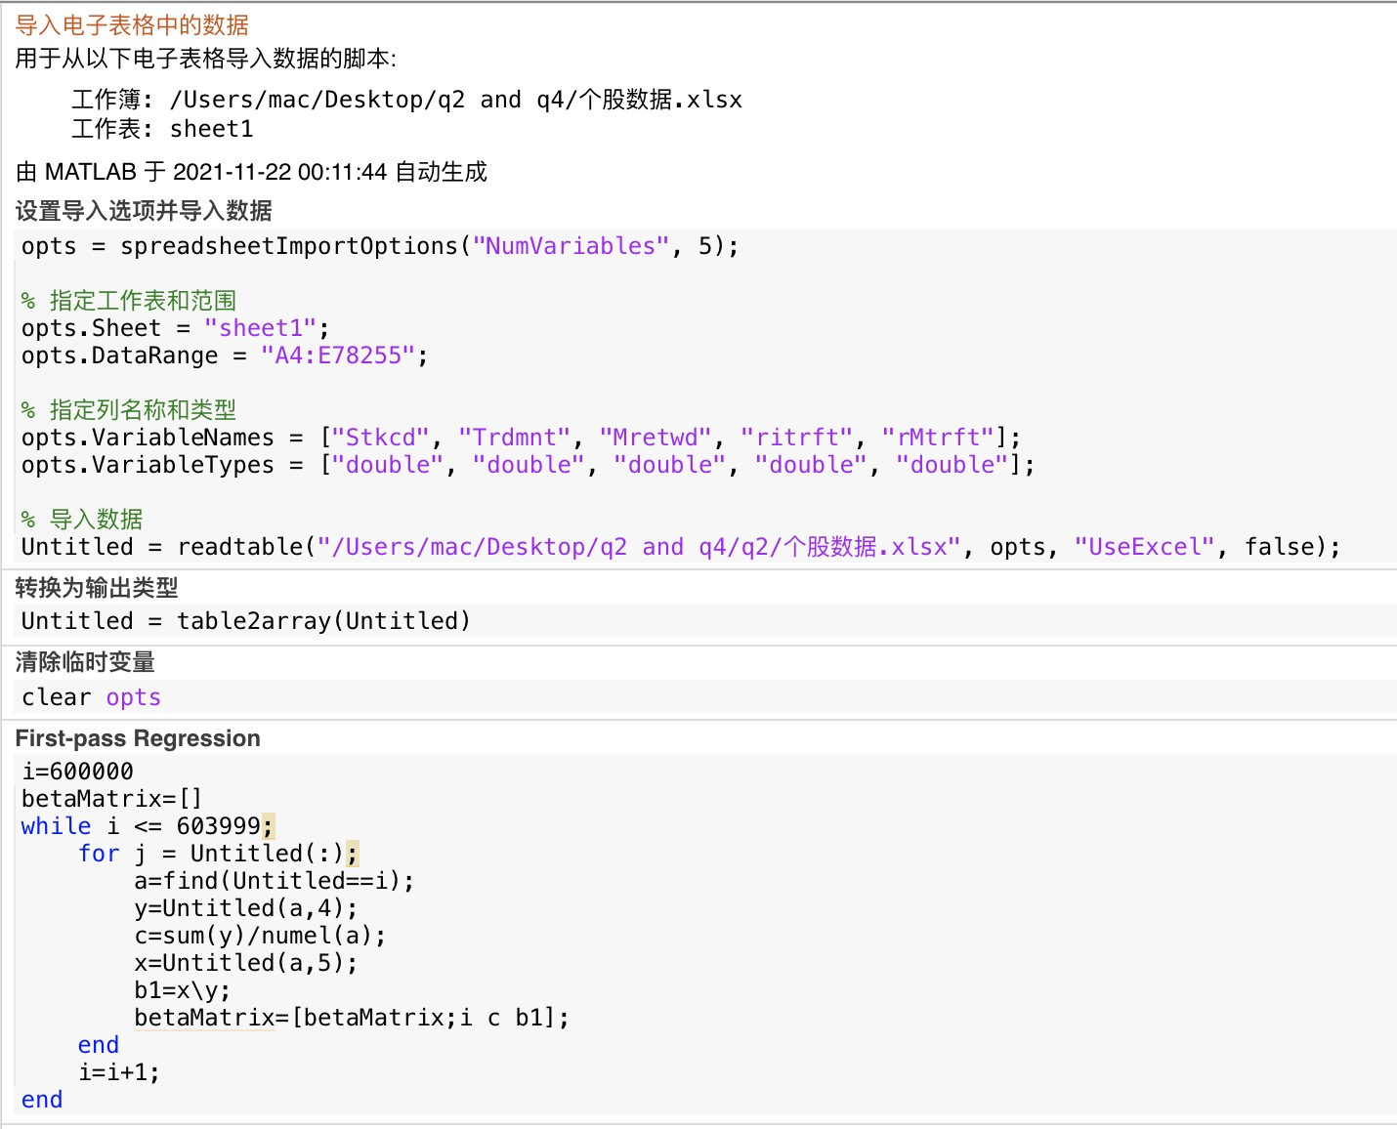

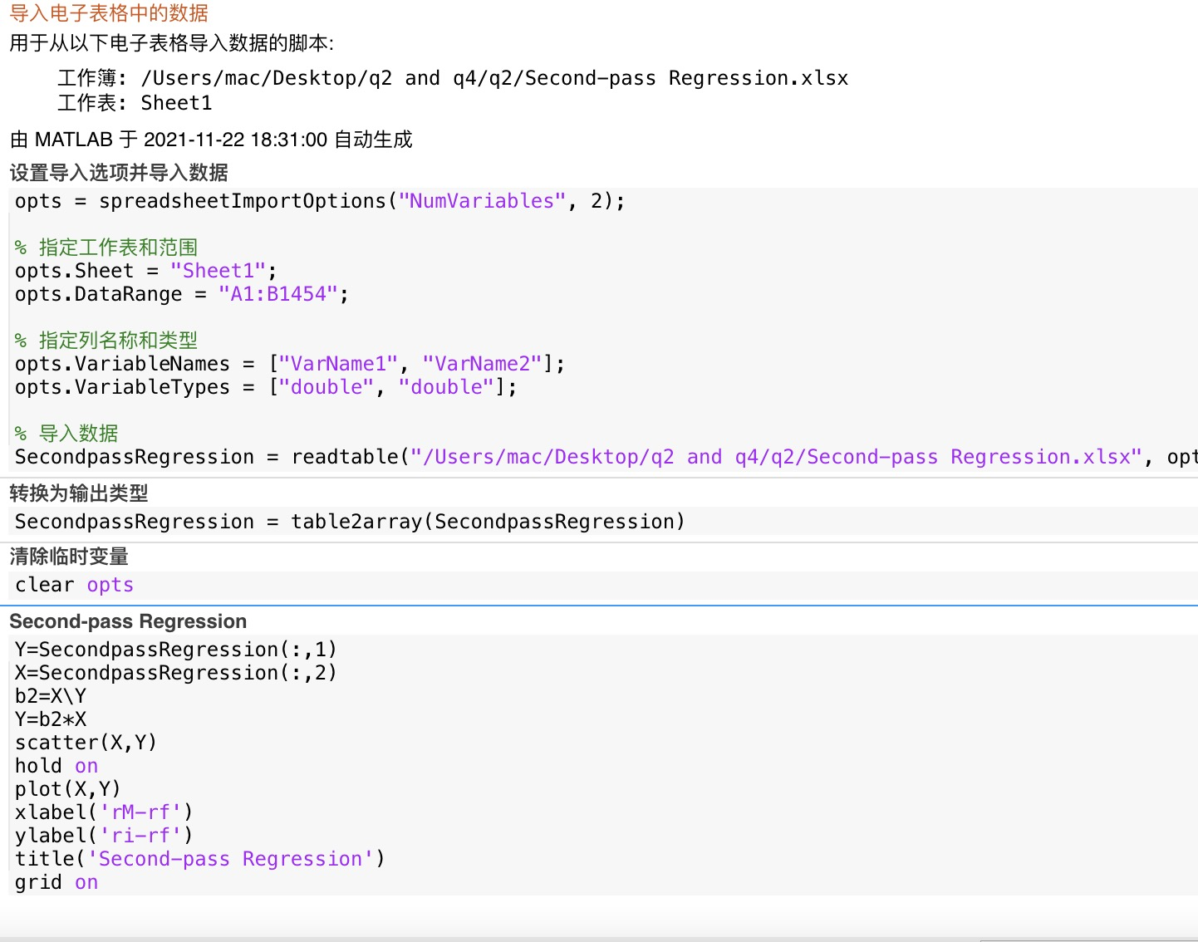

Output: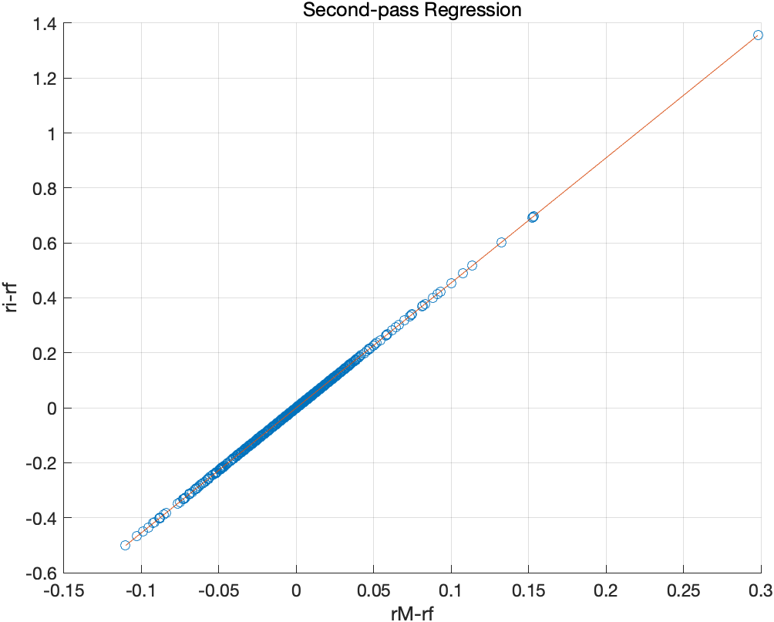

The beta2=4.5478.

2.1.4Model Test.

First we can see that ‘rit-rft’ is less than 0, which means that the return of risk-free asserts is higher than risky assert.

Hence, the CAPM is not established for A share Market.

The index on 2013.1--2385.422

The index on 2018.12--2493.896

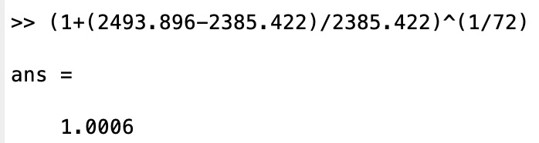

We used the index at the end of December 2018 and the index at the beginning of January 2013 to calculate the average monthly rate of the index, and found that it was far less than the risk-free interest rate for any time period. This can prove that the CAPM model is not suitable for the Chinese market.

2.2.Problem b

2.2.1.Breakpoints

We take 10% as breakpoints of the individual stocks, and we have np=10.

Calculate the beta coefficient of each individual stock, and put them into a matrix, and finally generate excel.

The code:

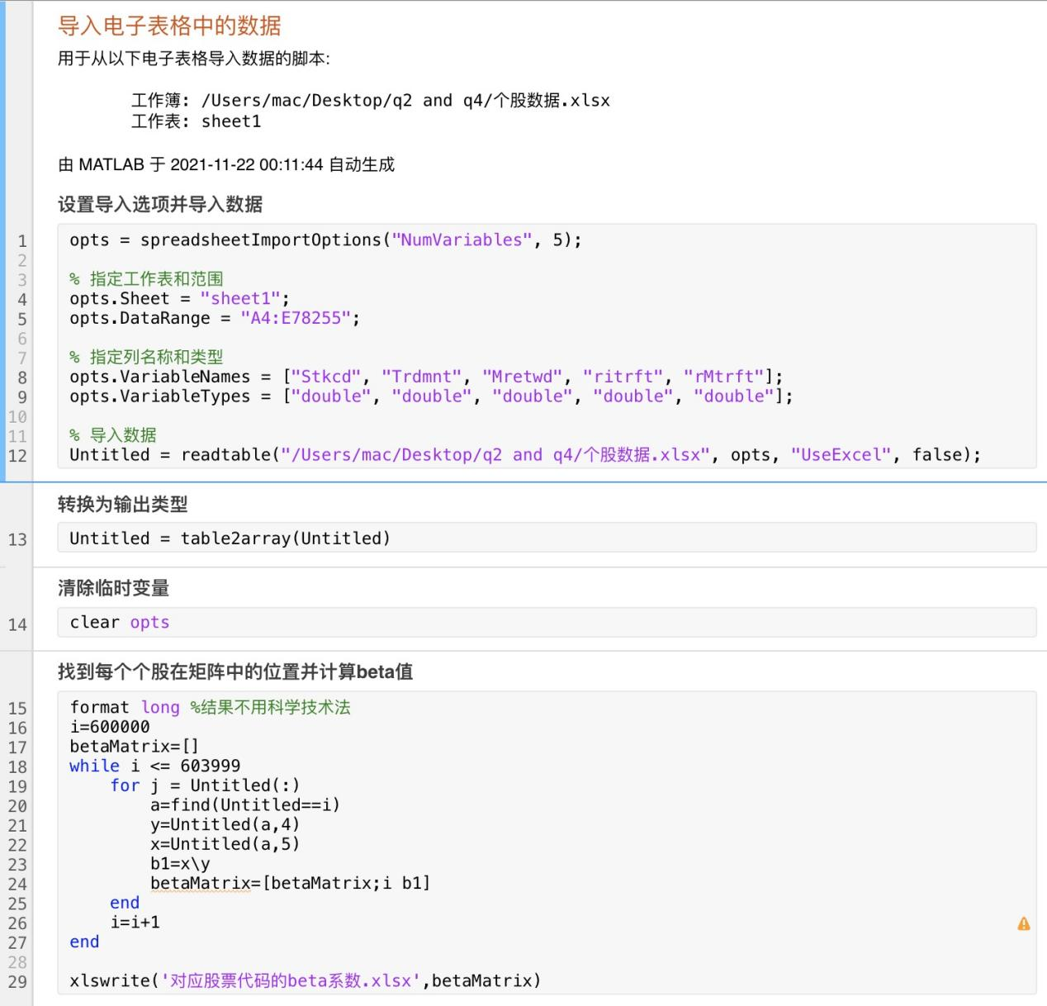

A part of outcome in Excel as shown:

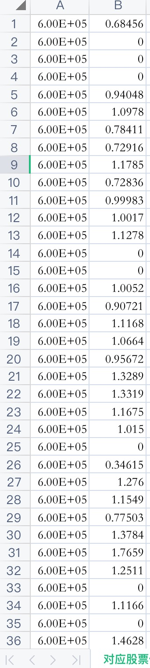

Items with a beta coefficient of 0 in Excel need to be eliminated. Because in the original stock code, these stock codes do not exist, but the algorithm can only add one per circle.

There are a total of 1454 beta coefficients, so it is divided into ten groups and each group has 145 samples.(In order to facilitate data processing, discard the four excess stocks.)

Sort the stocks according to the beta coefficient, and use each column vector in the large matrix to represent a portfolio.

The code:

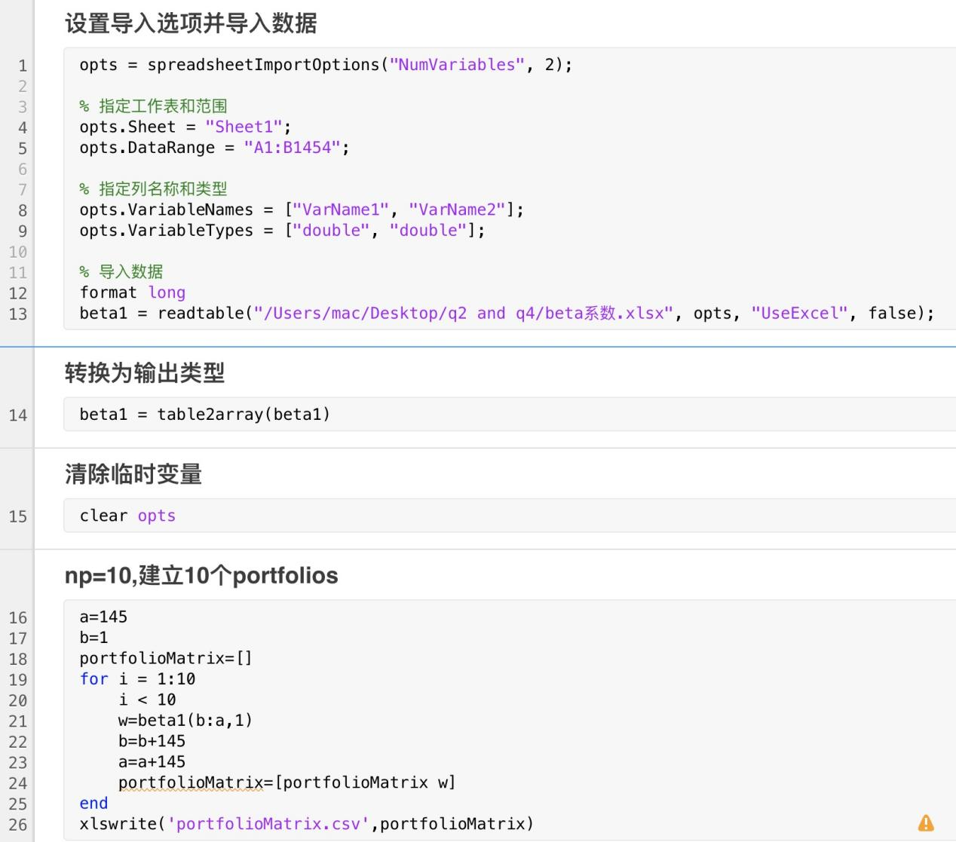

We get the matrix(only a part of it):

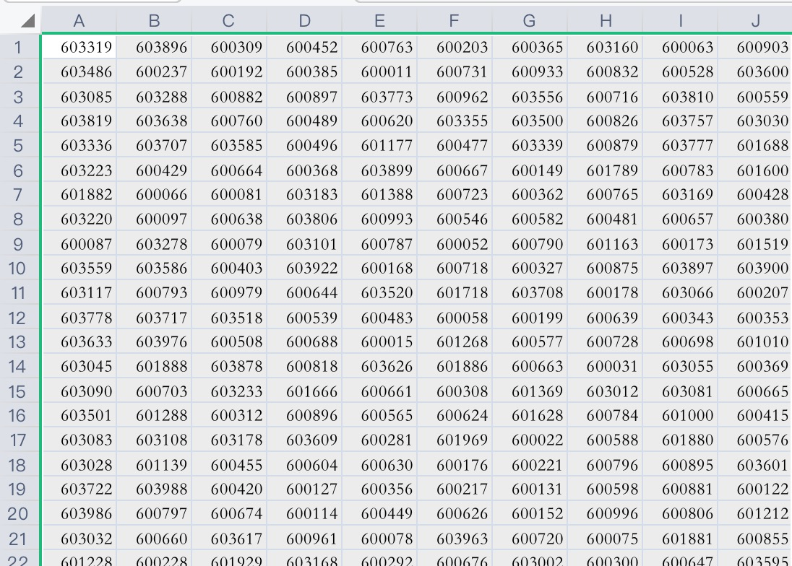

2.2.2.t-statistics

Calculate the beta coefficient of each investment portfolio, and calculate the standard error and average of ‘beta(np)-beta(n1)’.

The code:

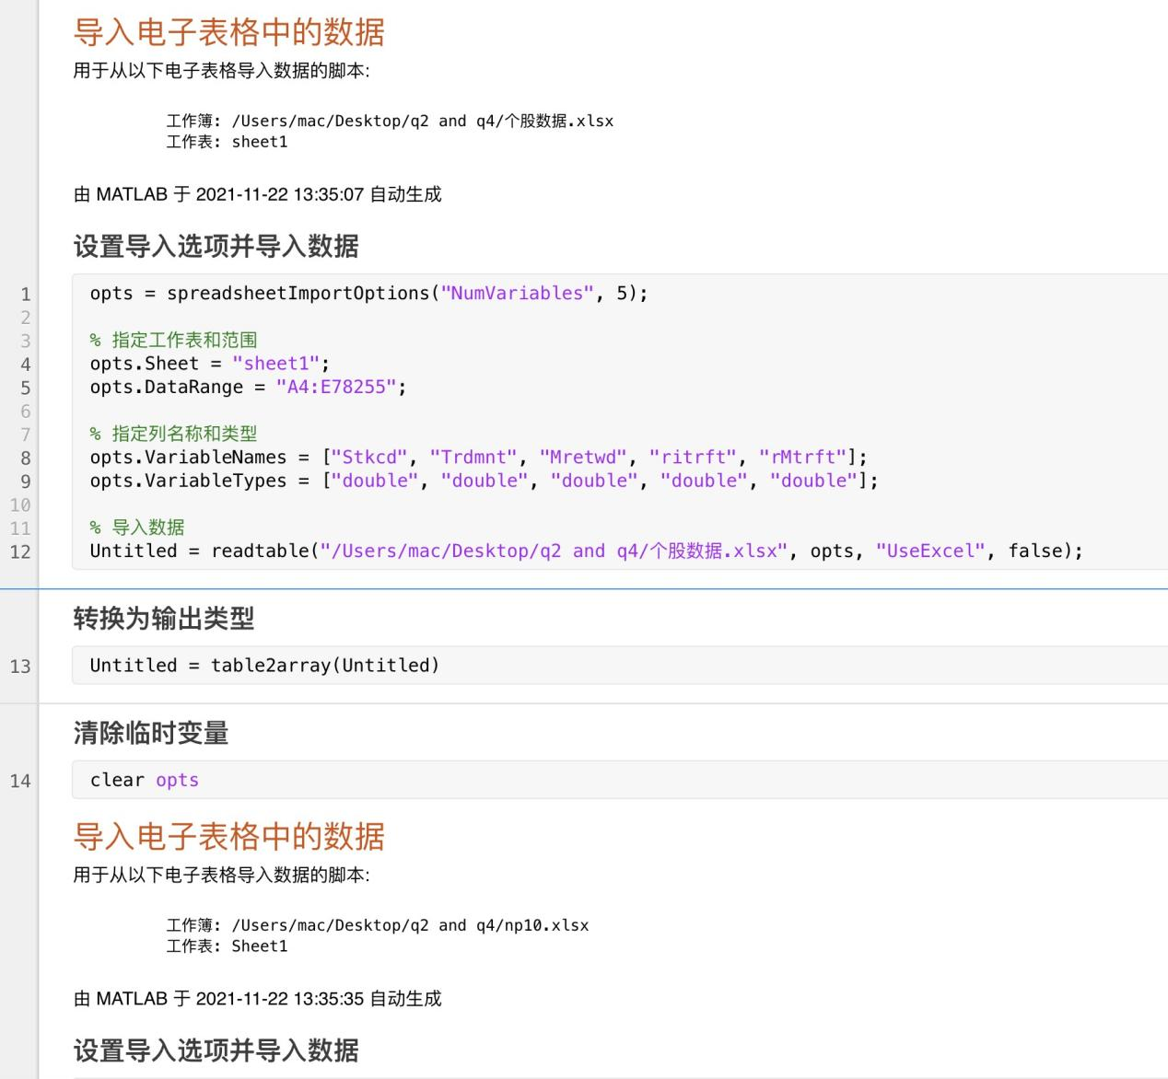

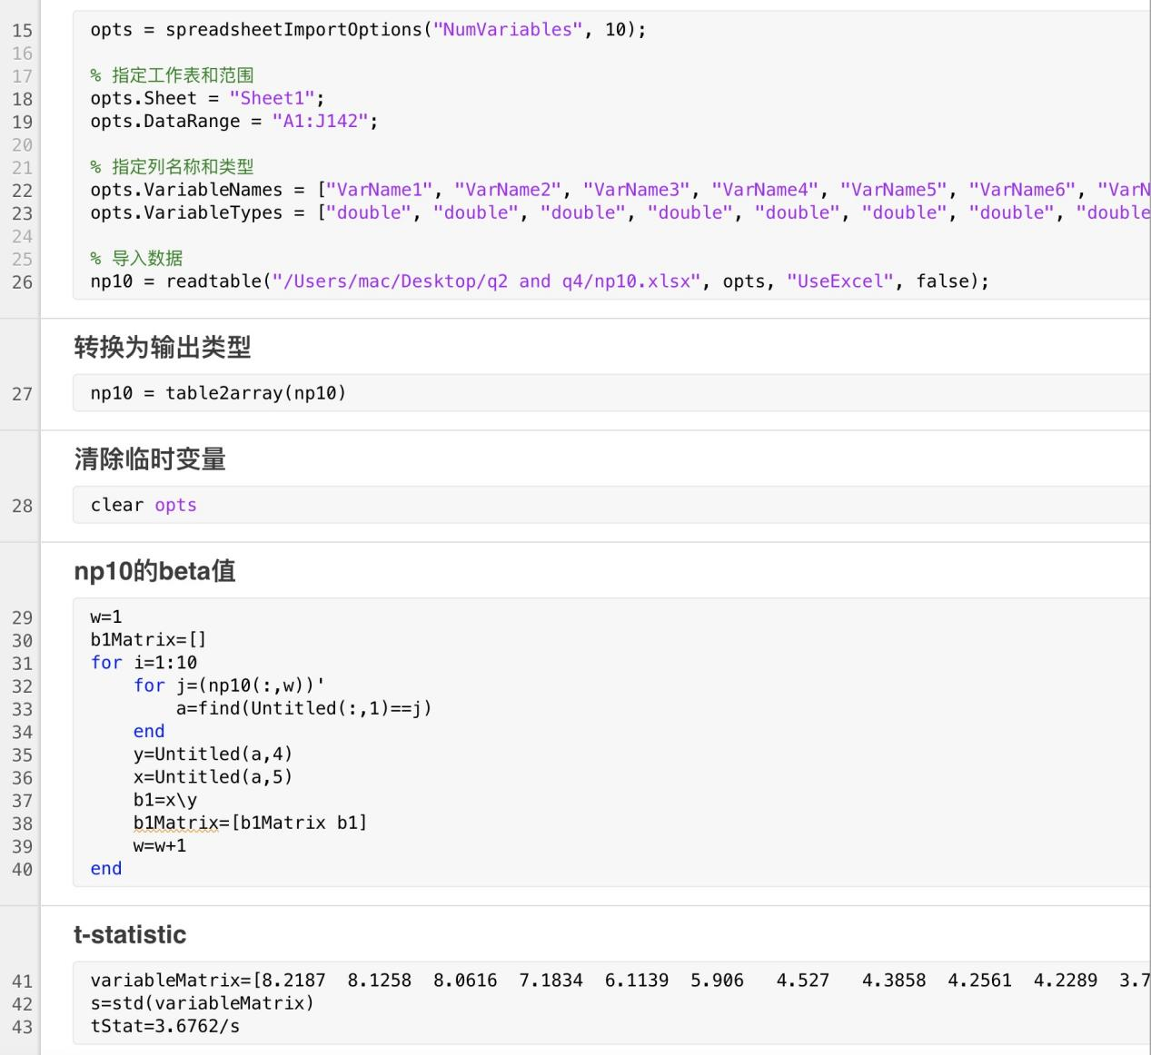

Outcome:



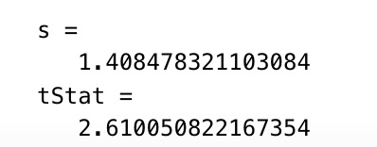

Hence, we get the table:

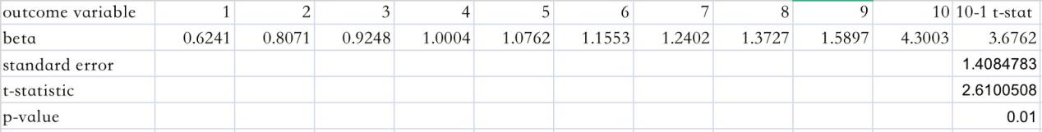

So we have 99% certainty to reject the null hypothesis.

Hence, through univariate portfolio sort, the CAPM is not established on A-share Market.

If you change the frequency, the result remains the same.

1. Reason Speculation.

3.1.A large number of stocks are non-tradable stocks, which makes asset pricing difficult.

3.2.China does not have a short-selling mechanism for individual stocks, which makes it impossible to sell stocks and buy risk-free assets for arbitrage.

3.3.Participants in China's financial markets are mostly irrational, causing stock prices to be erroneously pushed up.

3.4.The main purchasers of risk-free assets in China are financial intermediaries, and financial intermediaries are mainly state-owned assets. Other participants are likely to be restricted by policies and unable to participate in arbitrage activities in the national debt market.

3.5.China restricts capital inflows and outflows while restricting foreign investment activities, which has led to misallocation of funds.

3.6.The inability of the index to represent the market leads to index distortion.

h.The impact of the trade war in 2018 caused a sharp correction in the stock market.

Question 4 (Fama-French-3 Factor Model）

1.Data Samples and Data Sources

上证A股收益率 2010.1--2018.12

上证指数收益率 2010.1--2018.12

上证A股个股总市值(mkt) 2010.1--2018.12

账面市值比(BM) 2010.1--2018.12（可用PB倒数）

无风险利率(Rf) 2010.1--2018.12

Source: csmar

1. Data Processing



2.1Problem a

2.1.1Market risk premium factor

Use ‘Shanghai Stock Index Yield - Risk-Free Rate’ to get this factor.

It is easy to deal with through Excel.

As below figure shown(a part):

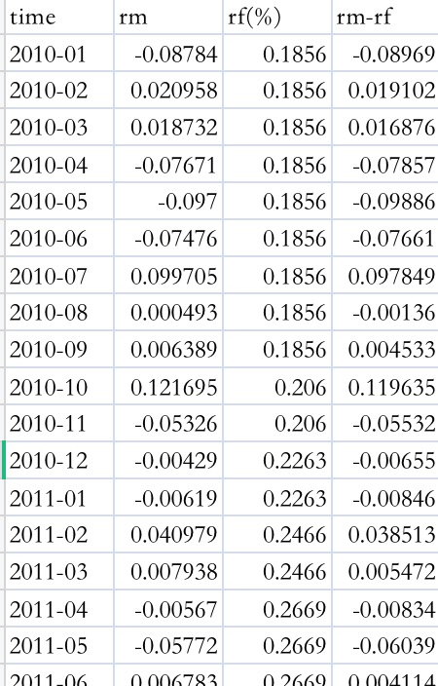

2.2.2 SMB factor and HML factor

The first is to divide individual stocks into two groups (Small and Big) according to their market capitalization at the end of January each year. The first 50% are in the Big group, and the last 50% are in the Small group; and then all stocks are individually divided according to the book-to-market value ratio. Divided into three groups (High, Medium, Low), the first 30% is the High group, the middle 40% is the Medium group, and the last 30% is the Low group. Therefore, from June of the current year to May of the following year, all stocks are divided into these 6 groups (B/L, B/M, B/H, S/L, S/M, S/H), this During the period, the grouping will not change, unless there is no transaction data. Then calculate the market value weighted rate of return for the 6 combinations in each trading month to obtain the rate of return of these 6 combinations; finally calculate the SMB factor and HML factor in each trading month, the calculation formula is as follows,(Sort once a year)

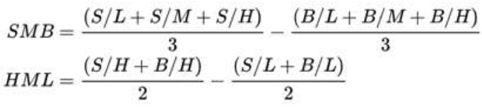

After program processing, we get SMB and HML.

A part of Excel as Shown,

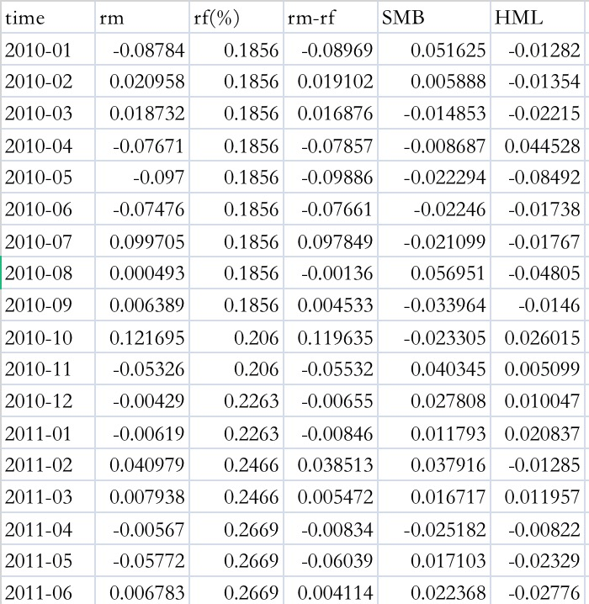

So far, the three-factor model has been established.

2.2Problem b